HOTEL MANAGEMENT SEQUENCE DIAGRAM

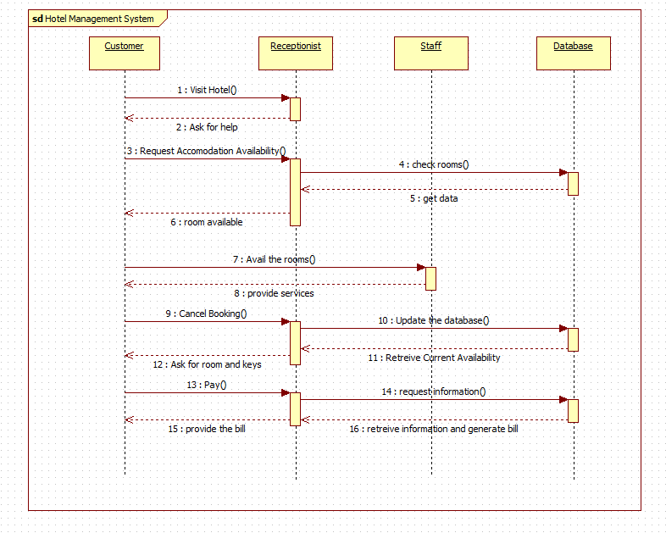

HOTEL MANAGEMENT ACTIVITY DIAGRAM

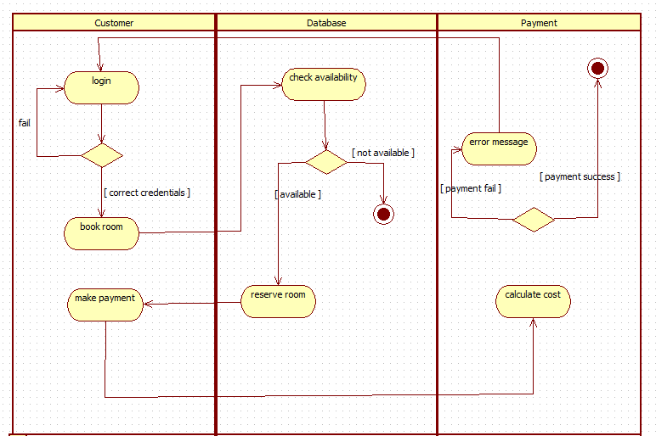

LIBRARY MANAGEMENT SEQUENCE DIAGRAM AND ACTIVITY DIAGRAM

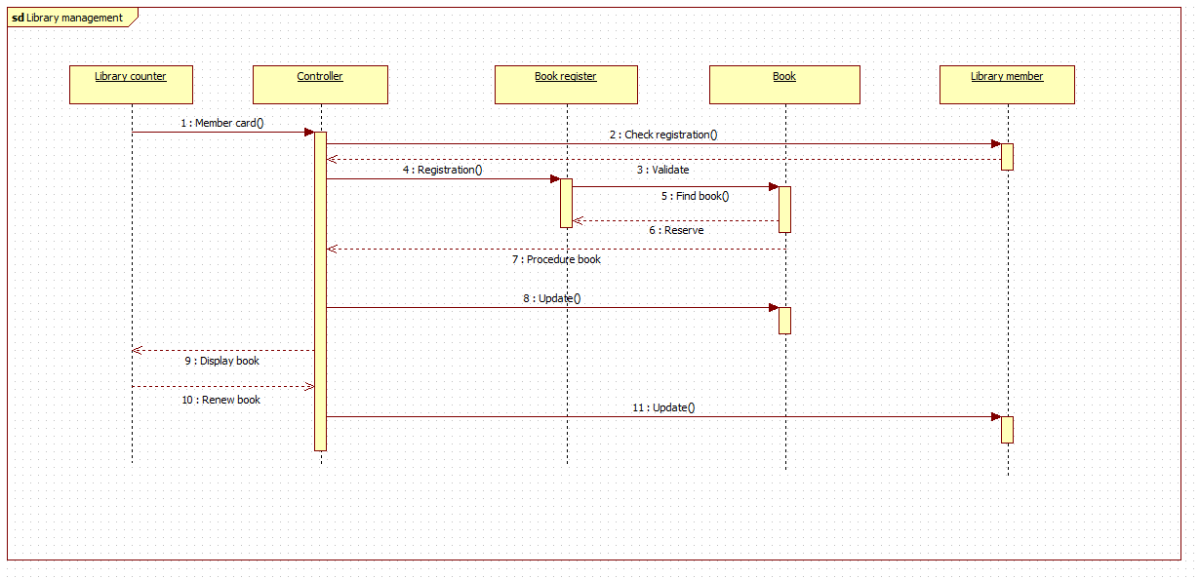

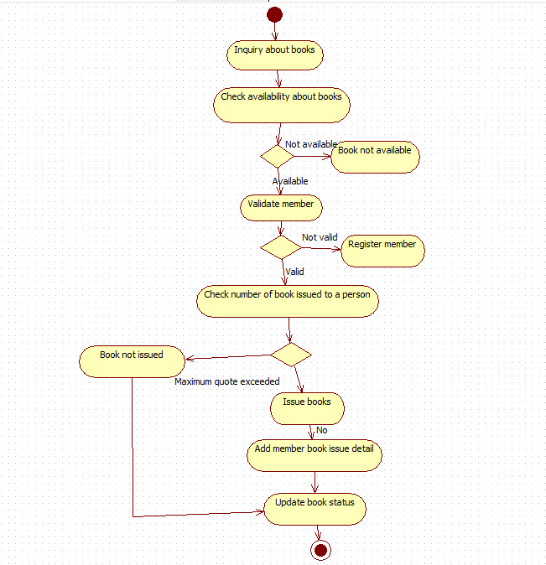

PASSPORT AUTOMATION SEQUENCE AND ACTIVITY DIAGRAM

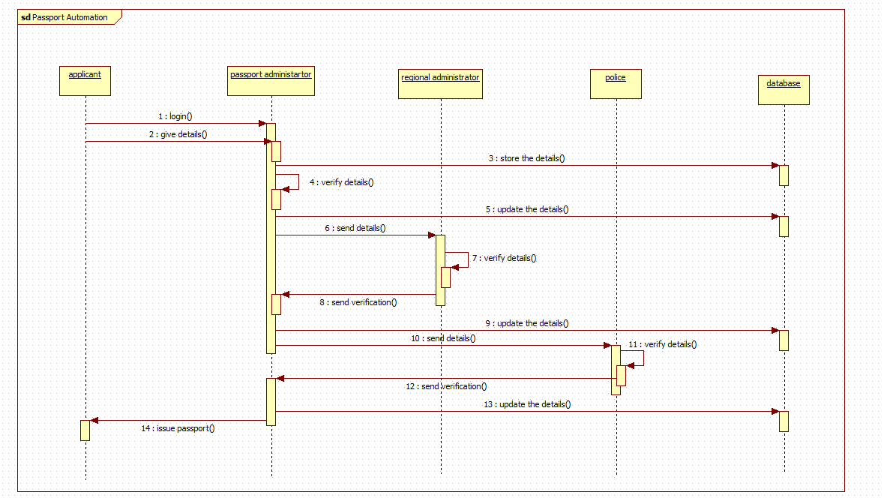

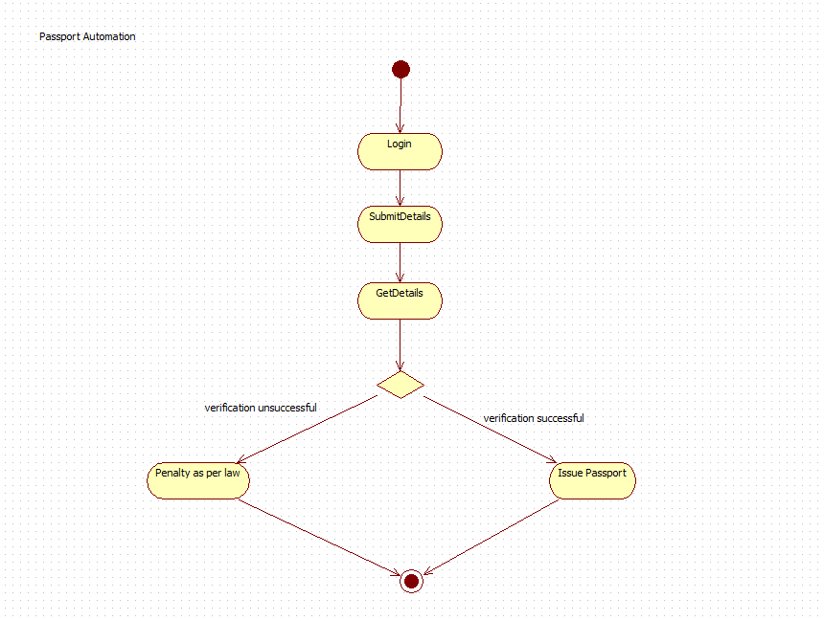

CREDIT CARD PROCESSING SEQUENCE AND ACTIVITY DIAGRAM

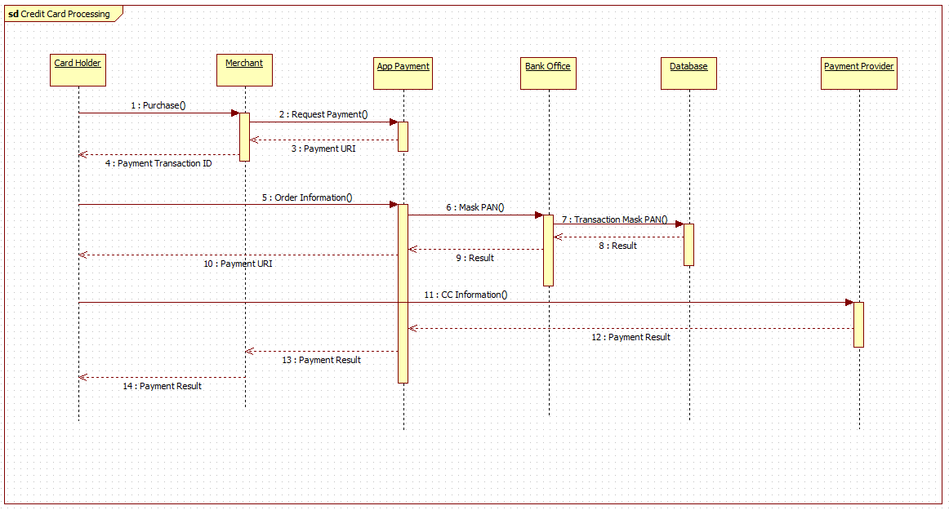

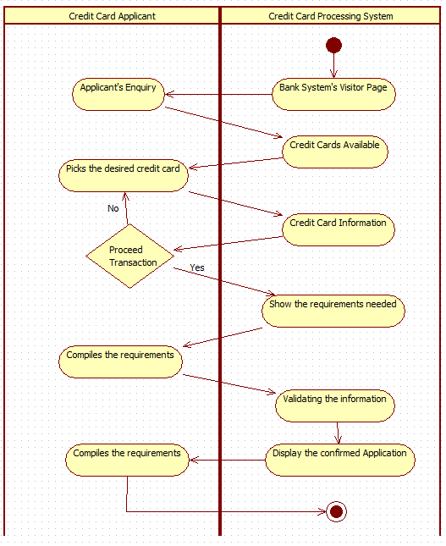

STOCK MANAGEMENT MAINTAINANCE SEQUENCE AND ACTIVITY DIAGRAM
